Derbyshire Medicines Management, Prescribing and Guidelines
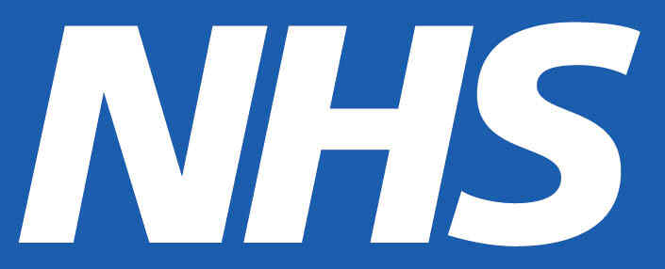
Derbyshire Primary Care Formulary

Guidance notes for choosing the correct emollient for your patient
Mild Dry Skin (Lotions/creams) | Moderate Dry Skin (Creams /ointments) | Severe Dry Skin  (Ointments)
ZeroAQS (alternative to Aqueous cream)  500g £3.29  Aquamax cream  500g £3.99  ZeroCream (alternative to E45)  500g £4.08  E45 lotion  500ml £4.50  E45 cream  500g £4.62  Dermol Lotion  (if antibacterial function required)  500ml £6.04  Dermol Cream  (if antibacterial function required)  500g £6.63 | Oilatum Junior Cream  500ml £4.99  Zerobase (alternative to Diprobase)  500g £5.26  Doublebase Gel  500g £5.83  Cetraben Cream  500g £5.99  Diprobase Cream  500g pump dispenser £6.32 | White soft paraffin 50% / liquid paraffin 50% ointment*  500g £2.36  Emulsifying Ointment*  500g tub £2.49  Zeroderm Ointment* (alternative to Epaderm)  500g £4.10  Hydromol Ointment*  500g tub £4.82  Epaderm Ointment*  500g tub £6.55
Products contain a variety of Excipients – please check before prescribing if patients have known sensitivities.
Prices for 500g are given for comparison, smaller sizes are available.
*National Patient Safety Agency Rapid Response Report 4 26/11/07. Reference to flammability of paraffin based products.
This is a guide only. Additional factors should be considered before prescribing any emollient. Please see overleaf.
Prices from Mims June 2013 or Drug Tariff June 2013

Emollient Prescribing Guide (June 2013)

